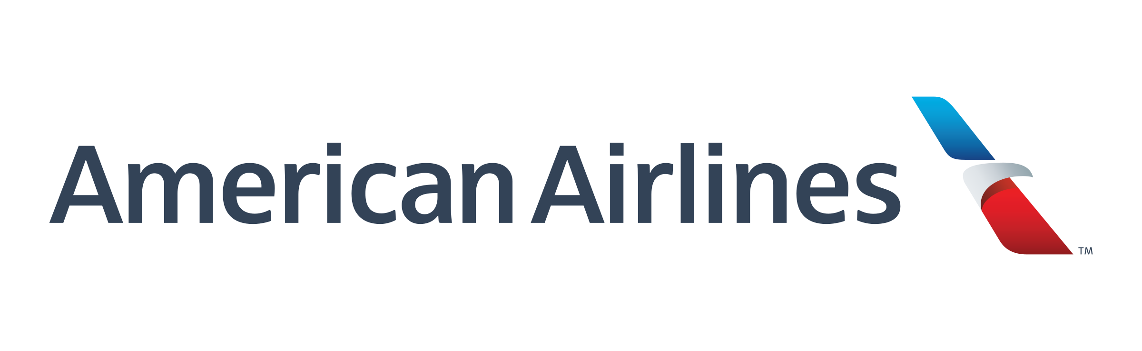

Cameron Stark

2337995

starkc1@my.erau.edu

Software Engineering

Summer 2019

American Airlines

Reliability Engineering Department

July 14, 2019

**Table of Contents**

1. American Airlines
   1. History of The Company
   2. Daily Operations of The Airline
   3. Future of The Airline
2. Projects
   1. ETOPS (Extended Operations) Data Access Application
      1. Background
      2. Customer
      3. Tech Stack
   2. 787 WAP (Wireless Access Point) Connection Dashboard
      1. Background
      2. Customer
      3. Tech Stack
   3. Aircraft Event Time Series Dashboard
      1. Background
      2. Customer
      3. Tech Stack
   4. Interiors Dashboard
      1. Background
      2. Customer
      3. Tech Stack
   5. Data Access Applications (Shiny Apps)
      1. Background
      2. Customer
      3. Tech Stack
   6. ACMS Database Data Access Application
      1. Background
      2. Customer
      3. Tech Stack
3. Conclusion
   1. Company Experience
   2. Future with Company

**Section 1: American Airlines**